Week 08
Problem Statement:
Coders here is a simple task for you, you have given an array of size N and an integer M.
Your task is to calculate the difference between maximum sum and minimum sum of N-M
elements of the given array.
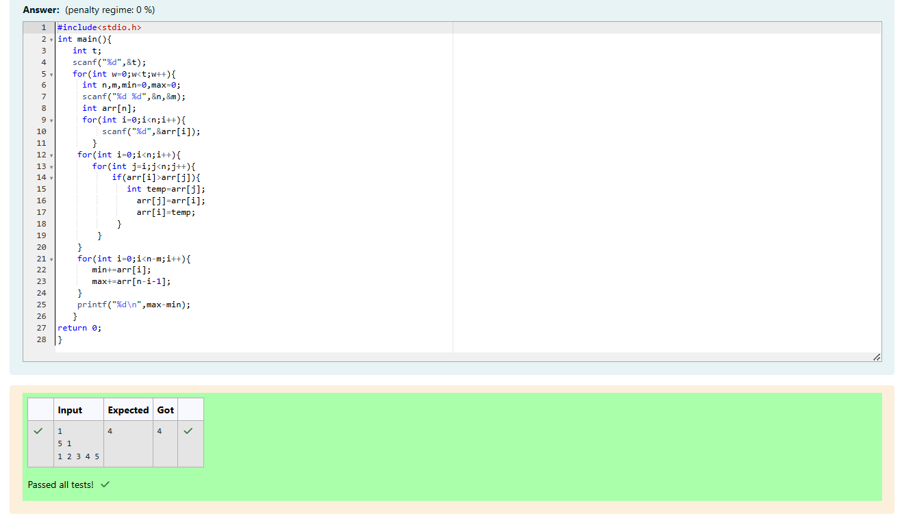

Problem Statement:
You are given an array A of non-negative integers of size m. Your task is to sort the array
in nondecreasing order and print out the original indices of the new sorted array.
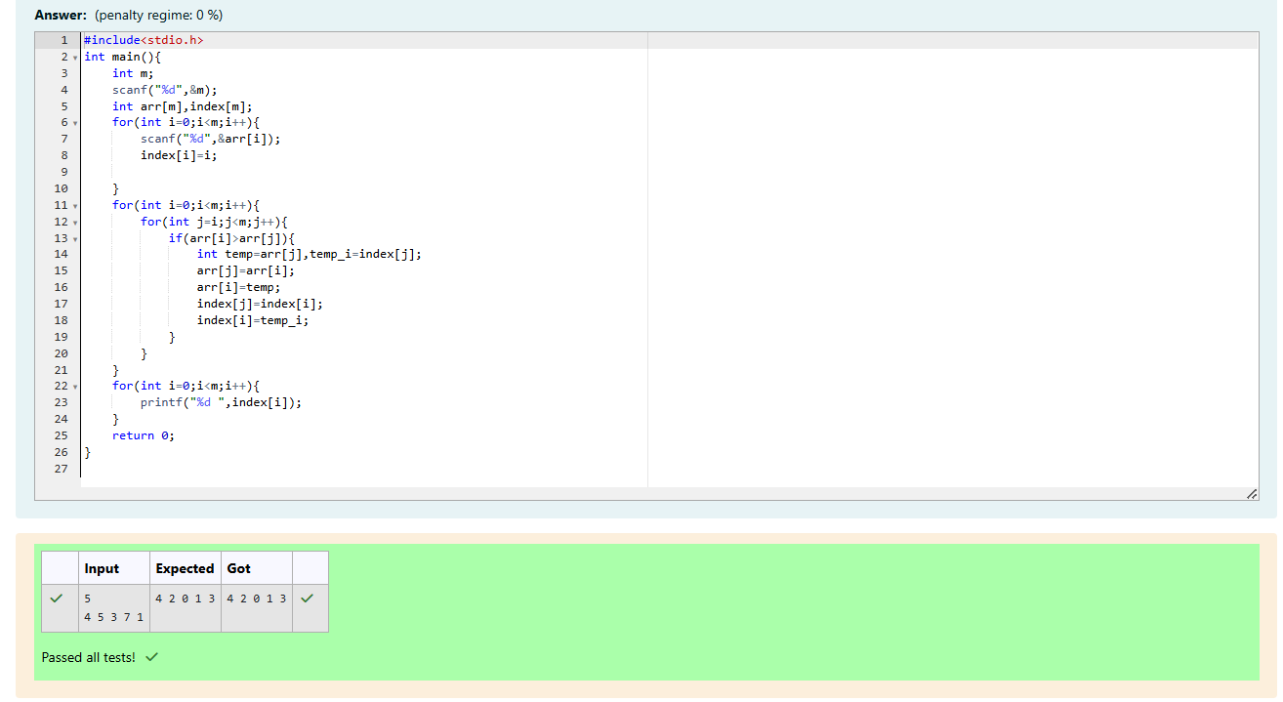

Problem Statement:
A new deadly virus has infected large population of a planet. A brilliant scientist has
discovered a new strain of virus which can cure this disease. Vaccine produced from this
virus has various strength depending on midichlorians count. A person is cured only if
midichlorians count in vaccine batch is more than midichlorians count of person. A doctor
receives a new set of report which contains midichlorians count of each infected patient,
Practo stores all vaccine doctor has and their midichlorians count. You need to determine
if doctor can save all patients with the vaccines he has. The number of vaccines and
patients are equal.
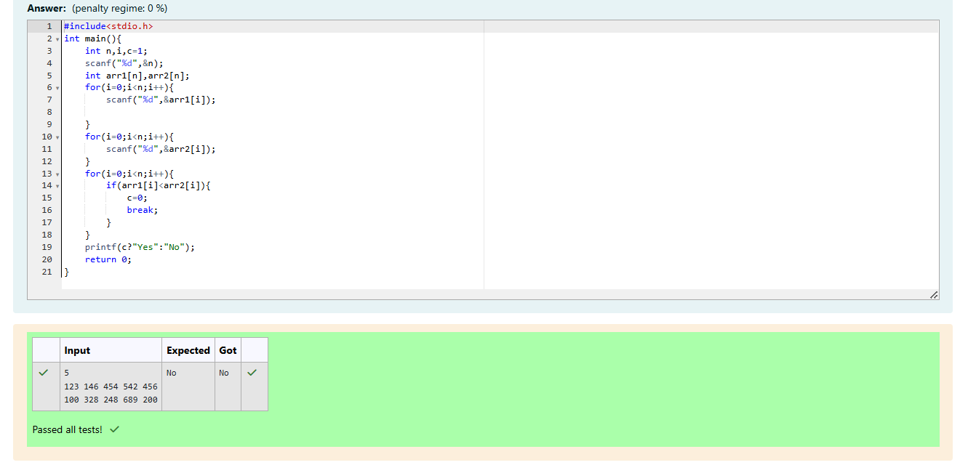

Problem Statement:
You are given an array of n integer numbers a1, a2, . . . , an. Calculate the number of pair
of indices (i, j) such that 1 ≤ i < j ≤ n and ai xor aj = 0.

